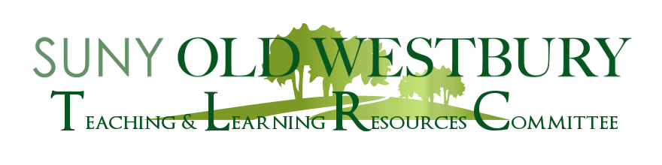

Co-Sponsored by CETL, The Writing Center, and WAC

**SAVE THE DATE**

**Artificial Intelligence in Academia**

**The Third in a Series**

**Possibilities, Perils, and Pitfalls:**

**The Impact of Chat GPT on College Writing**

A faculty workshop led by:

**Dr. Kathleen Weisse**

**Director of the Writing Center and Professional Lecturer in English**

**Marist College**

**Monday, April 17th**

**2:40 pm- 3:40 pm**

**via Zoom**

**Meeting ID: 649 730 1026**

**Passcode: 41723**

For faculty teaching with writing, ChatGPT marks a moment of necessary introspection and adjustment in terms of how we approach writing in the classroom. In this workshop, participants will consider the ways in which ChatGPT might inform our students’ approach to writing, learn best practices for writing assignment design in the age of AI, and collectively imagine ways we can work proactively to promote positive uses of ChatGPT and other AI writing programs. This presentation will involve a small-group activity and large group discussion, so participants should come ready to talk and strategize with their colleagues.